11 stylish balloon DIY's for your child's next party

The hottest trend in kids (and adults) parties right now is surprisingly the humble balloon. Yes, they have officially made their comeback – but on a whole other level.
The beauty of this trend is that balloons are easy to find, inexpensive and with our help, can be made into some of the most spectacular party decorations around.
Let us show you our favourite balloon creations;

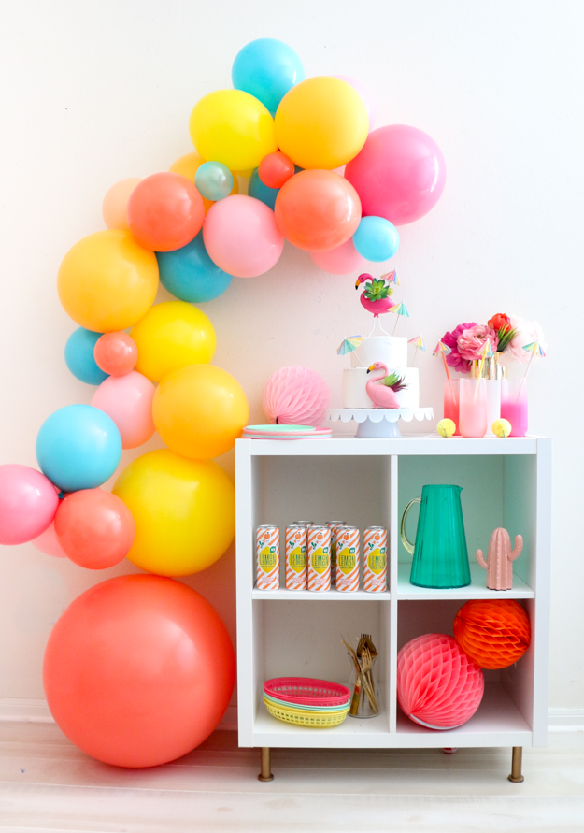

We love this simple yet effective balloon installation by A Kailo Chic Life, for a kids party, it would look great around the present or food table. If you’re hosting the party somewhere other than your house it could easily be put it together beforehand and transferred in a large garbage bag – that’s a win. Get the full balloon installation DIY here.

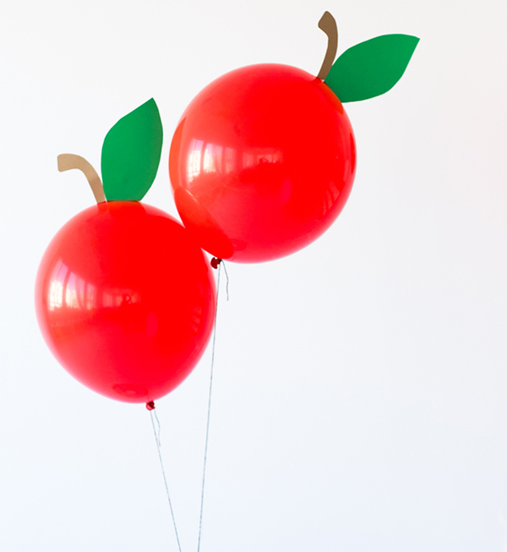

These DIY apple balloons by Studio DIY would be perfect for a Hungry Caterpillar Party (while we are at it, how cute is this Very Hungry Caterpillar Cake!) Check out the full Apple Balloon Tutorial.

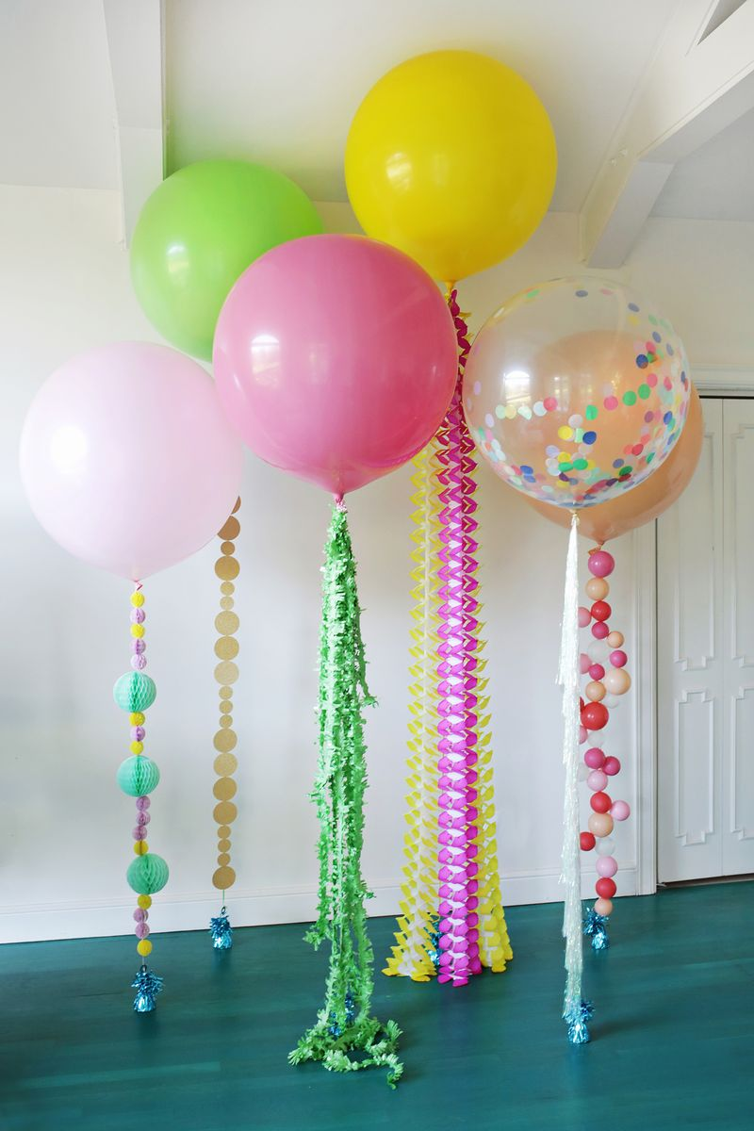

If you love the idea of simple, statement pieces these decorated balloon string ideas by A Beautiful Mess are all sorts of amazing! You could use such a huge array of crafty bits to tie it into your party theme. The possibilities are seriously endless. Get the biggest balloons possible though, you’re going to need some helium power to hold up all that fun.

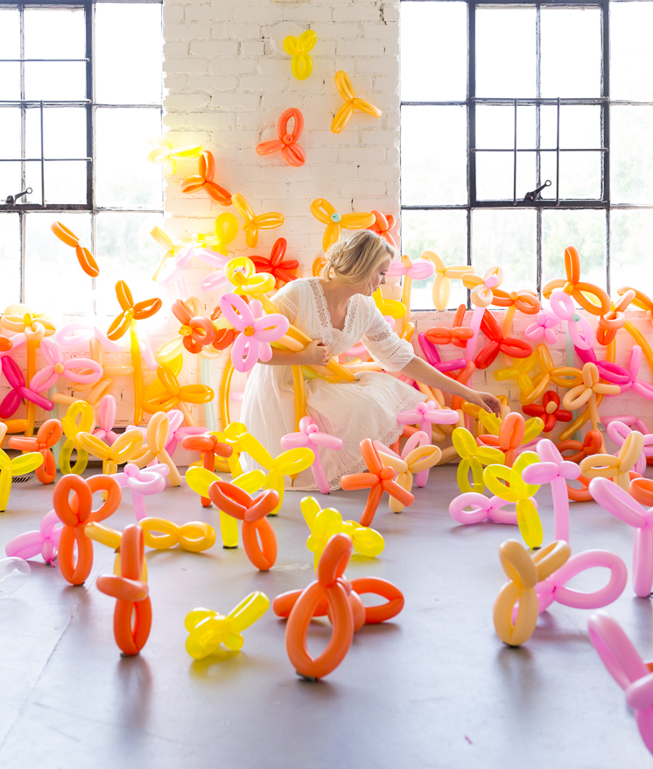

Ok, so maybe this particular installation by The House That Lars Built is a little hectic for a room full of small children, but you could absolutely dial it down to a cute flower garden for a fairy party. Isn’t it gorgeous? It’s a really good example of how a good colour scheme is key to your balloon creations looking stylish!

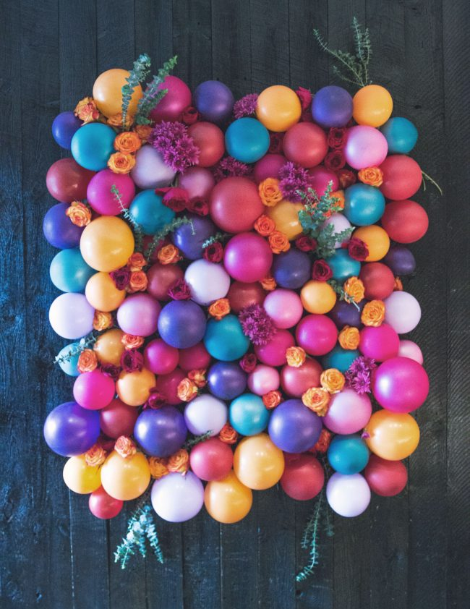

If your kids are getting a little older and don’t want to play with balloons anymore (sigh) you should be able to sufficiently impress them with this ah-mazing balloon backdrop by Sisoo. Perfect as a photobooth backdrop, decoration behind the food table or just about anywhere in the party vicinity. Not just for kids.

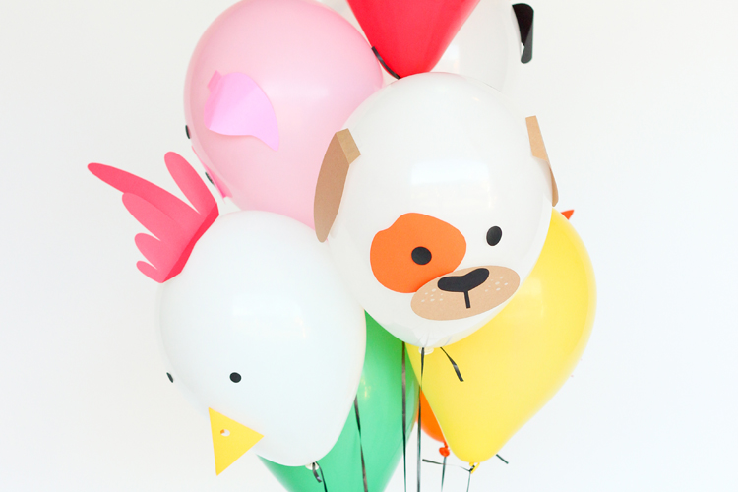

But for the little ones, these paper-cut animal balloons by Delia Creates are perfect. Imagine these in a farmyard themed first birthday party, you could use them as decoration and hand them out at the end in lieu of party bags. Or you could have the kids decorate them as a party activity. Whichever way you choose, they make a super cute statement.

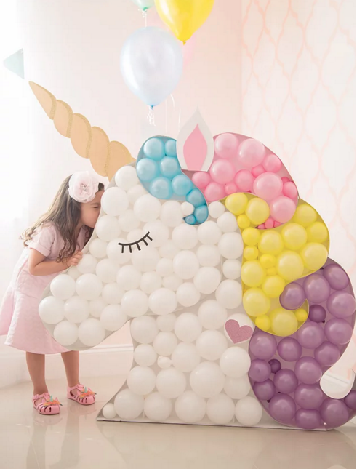

And there’s no way we could ignore the mighty unicorn, the staple of little girls party themes. We couldn’t pick just one so we are going to pop in a few. Like this insane balloon unicorn head by The Creative Studio. We admit it’s next level so that’s why we have also included a more realistic DIY idea below.

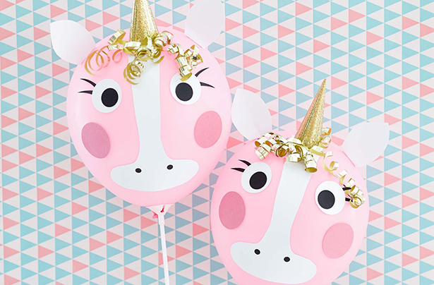

These cute-and-a-bit-hilarious DIY unicorn balloons by Hello Wonderful had us chuckling away all afternoon. They are sweet and funny, and even the most craft-challenged person could master these – also there is no helium necessary so that’s a win!

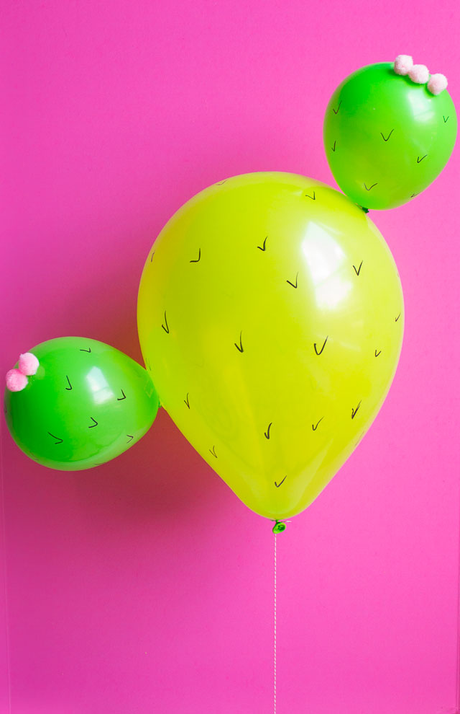

For something a bit more random, these DIY Cactus balloons by Design Improvised would be perfect for a Lightning McQueen or Wild West themed party. Bonus, on a scale of one to ten, where one is 'easy' and 10 is a 'giant unicorn head', they are a firm three.

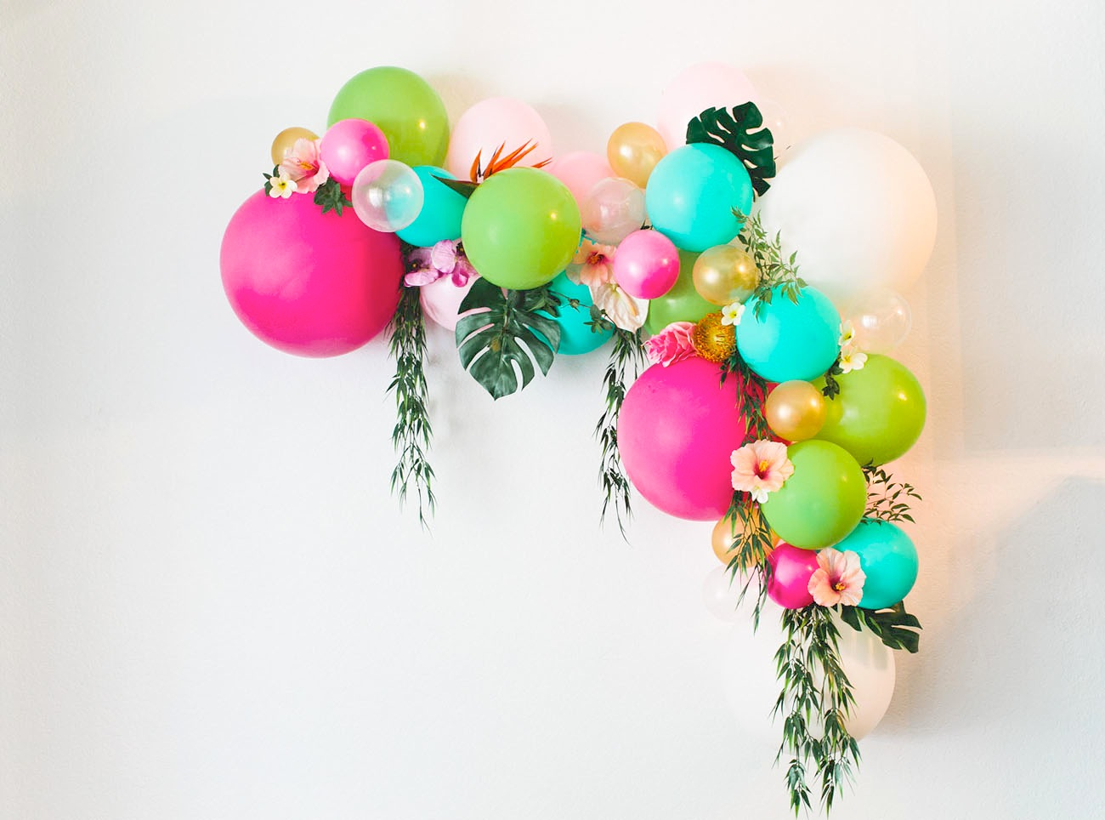

If it’s a Moana party your child is after, this DIY Floral Balloon arch by Green Wedding Shoes is a total winner. Yes, it may be more ‘giant unicorn head’ than 'cactus balloon' but it’s totally worth the effort. We are very smitten with this DIY.

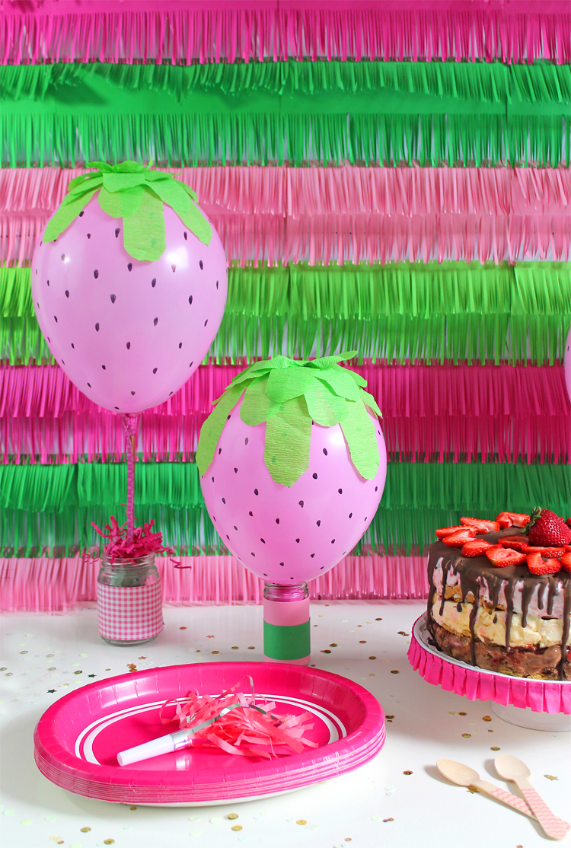

Finally, to finish on a realistic note, these strawberry balloons by The Craft Patch are very cool and not at all insane. All you need is a balloon, a sharpie and some crepe paper; no helium required. To be honest, we think they are the cutest of the lot.

Happy partying!

